**End-Term Project report on**

**Cloud-Enabled Automatic Number Plate Recognition System with ESP32-CAM for Smart Surveillance Applications**

Submitted by

**Ritesh Mohanty (2241013269)**

**Jyotismita Nath (2241014044)**

**Satyajit Sahu (2241019222)**

**Ankit Kumar (2241011102)**

**B. Tech. (CSE(IOT) 5th Semester (Section–2241009)**



**DEPARTMENT OF COMPUTER SCIENCE AND ENGINEERING**

Institute of Technical Education and Research

**SIKSHA ‘O’ ANUSANDHAN**

**DEEMED TO BE UNIVERSITY**

Bhubaneswar, Odisha, India.

(December, 2024)

# Abstract

The "Cloud-Enabled Automatic Number Plate Recognition System with ESP32-CAM" leverages the Internet of Things (IoT) and cloud-based machine learning for smart surveillance applications. The system employs an ESP32-CAM module to capture images of vehicle number plates when triggered via a push-button switch. These images are transmitted to a cloud-based API, where machine learning algorithms process and recognize the alphanumeric content of the number plate. The recognized data is sent back to the system and displayed on an OLED screen for real-time observation.

This project addresses critical challenges in automating vehicle tracking and monitoring for security and traffic management applications. By integrating IoT and machine learning, the system achieves high accuracy in plate recognition while being cost-effective and compact. Potential applications include automated toll collection, parking management, and smart city surveillance systems.

Key features of the system include wireless data transfer, cloud integration for scalable processing, and OLED-based data presentation. Limitations such as dependency on internet connectivity and variable lighting conditions for image clarity are acknowledged. Future enhancements may involve offline processing capabilities, broader recognition ranges, and more advanced security mechanisms.

Moreover, this system demonstrates the potential for scalable deployment in a wide range of environments, from urban settings to industrial zones. Its modular architecture allows for easy customization and integration with additional components, such as vehicle tracking systems, alert mechanisms, or data analytics platforms for traffic flow analysis. By utilizing cloud-based machine learning, the project not only ensures flexibility in handling large datasets but also reduces the computational burden on local hardware. This makes it a practical and forward-thinking solution for modern surveillance and automation needs, paving the way for further innovations in IoT-based smart monitoring systems.

The project also emphasizes sustainability and energy efficiency by using minimal hardware components and leveraging the cloud for heavy computational tasks. This approach reduces overall system costs while maintaining high performance. Additionally, the integration of machine learning ensures adaptability, as the recognition models can be updated and retrained to handle new types of license plates or evolving requirements. Such a system not only addresses current surveillance challenges but also sets a foundation for future advancements, including multi-vehicle monitoring, advanced analytics, and integration with smart city infrastructure.

# Contents

Abstract i

Contents ii

Chapter 01: Introduction 1

1.1. Introduction 1

1.2. Background 1

1.3. Project Objectives 2

1.4. Scope 3

1.5. Project Management 5

1.6. Overview and Benefits 5

1.7. Organization of the Report 7

Chapter 02: Background Review & Survey 8

2.1. Related Works 8

3.1. Internet of Things (IoT) 10

3.2. Features of IoT 10

3.3. Advantages of IoT 10

3.4. Disadvantages of IoT 11

3.5. Application areas of IoT 11

3.6. IOT Technologies and Protocols 11

3.7. Project Layout 12

3.7.1. Brief Description 12

Chapter 04: Hardware Requirements 14

5.1. ESP-32 CAM: The main microcontroller with a built-in camera module for capturing images of number plates. 14

5.1.1. Features: 14

5.1.2. Pin Configuration 14

5.2. Programmer or USB-to-TTL Converter: 15

To program the ESP32-CAM as FTDI it lacks a native USB interface. 15

5.3. OLED Display: To display the number of the vehicle. 15

5.4. Breadboard and some connecting wires. 15

5.5. Block diagram of the proposed system 15

5.5.1. Working of the system 16

5.5.2. Circuit Diagram 17

5.5.3. Components Required 17

7.1. Arduino IDE (Embedded C / C++): Used for writing, compiling, and uploading the code to the ESP32-CAM module. 18

7.2. ESP32 Board Support Package: Required to program the ESP32-CAM board in the Arduino IDE. 18

7.3. Required Libraries: Adafruit GFX Library, Adafruit SSD1306 Library, WiFiClientSecure, esp_camera. 18

7.4. API Server: backend API capable of processing images and extracting number plate information. 18

7.5. Logic and Flowchart 18

Chapter 06: Project development & Testing Aspects 20

8.1. Overview of Project Development 20

Chapter 07: Conclusion & Future Scope 30

9.1. Result 30

9.2. Conclusion 31

9.3. Limitations 32

9.4. Further Enhancement and Future Scope 32

References 33

Appendix 01 34

A01.1. Code Listing 34

A01.2. Main Code 34

A01.3. Libraries 34

Appendix 02 35

A02.1. Project Proposal Form 35

A02.2. Project Management 35

A02.3. Bill of Material 35

Appendix 03 36

A03.1. Data Sheets 36

# Chapter 01: Introduction

## Introduction

In the rapidly advancing field of surveillance technologies, automatic number plate recognition (ANPR) systems have emerged as pivotal tools for traffic management, law enforcement, and security monitoring. These systems are instrumental in automating the detection and identification of vehicles, thereby reducing human intervention and enhancing operational efficiency. The integration of cloud computing with ANPR systems further extends their capabilities, enabling real-time data processing, remote accessibility, and scalable storage solutions.

This project presents a **Cloud-Enabled Automatic Number Plate Recognition System** utilizing the versatile ESP32-CAM module, tailored for smart surveillance applications. The ESP32-CAM, a low-cost microcontroller with built-in camera capabilities, provides a compact and cost-effective platform for implementing edge-based image capture and processing. By leveraging cloud computing, the system ensures robust data management, advanced analytics, and seamless integration with other smart systems.

Key features of this project include real-time vehicle detection, optical character recognition (OCR) for license plate decoding, and a cloud-based database for storing and retrieving vehicle information. This integration facilitates a wide array of applications, such as automated toll collection, parking management, and monitoring of restricted areas, aligning with the growing demand for smart cities and IoT-driven solutions.

The proposed system offers a scalable, efficient, and user-friendly approach to modern surveillance challenges, combining cutting-edge hardware with the power of cloud technologies to enhance security and operational efficiency.

## Background

The increasing complexity of urban infrastructure and the rapid growth in vehicle populations have posed significant challenges to traffic management and security monitoring. Conventional methods of vehicle identification, often reliant on manual inspection, are time-consuming, prone to errors, and lack scalability. This has led to the emergence of Automatic Number Plate Recognition (ANPR) systems, which employ image processing and machine learning techniques to identify vehicles based on their license plates.

ANPR systems have been widely adopted in various applications, including toll collection, parking management, and law enforcement. These systems eliminate the need for manual intervention, improving accuracy and efficiency. However, traditional ANPR systems are often resource-intensive, requiring high-end hardware and substantial computational power, which can increase costs and limit deployment in resource-constrained environments.

Recent advancements in Internet of Things (IoT) and cloud computing have created opportunities to overcome these limitations. IoT devices, such as the ESP32-CAM, offer cost-effective and compact solutions for edge-based data collection and processing. When combined with cloud computing, these devices enable real-time data transmission, analysis, and storage, significantly enhancing the functionality and scalability of ANPR systems.

The ESP32-CAM, a low-cost microcontroller equipped with a camera module and Wi-Fi capabilities, is well-suited for this purpose. Its ability to capture and process images locally while communicating with cloud platforms makes it an ideal choice for smart surveillance applications. By leveraging cloud services, ANPR systems can offload computational tasks, enabling real-time analytics, centralized management, and improved decision-making.

This project builds on these technological advancements to develop a Cloud-Enabled Automatic Number Plate Recognition System. By integrating the ESP32-CAM with cloud-based services, the system addresses the limitations of traditional ANPR solutions, offering a lightweight, scalable, and efficient platform for smart surveillance. This approach not only enhances security and traffic management capabilities but also aligns with the vision of sustainable smart cities.

## Project Objectives

* The primary goal of this project is to design and implement a **Cloud-Enabled Automatic Number Plate Recognition (ANPR) System** using the ESP32-CAM module for smart surveillance applications. The specific objectives are as follows:

1. **Develop an ANPR System:**

* Build a robust system capable of detecting and recognizing vehicle license plates in real-time using the ESP32-CAM module and image processing techniques.

1. **Leverage Cloud Integration:**

* Incorporate cloud computing services for efficient data storage, processing, and retrieval.
* Enable real-time analytics and remote monitoring through a cloud-based interface.

1. **Optimize System Performance:**

* Minimize latency in image capture, processing, and data transmission by utilizing the edge computing capabilities of the ESP32-CAM.
* Ensure high accuracy in license plate detection and recognition under varying environmental conditions.

1. **Design for Scalability and Cost-Effectiveness:**

* Create a solution that is scalable to accommodate multiple devices and large volumes of data.
* Utilize the low-cost ESP32-CAM module to ensure affordability and accessibility for various applications.

1. **Enhance Smart Surveillance Applications:**

* Demonstrate the system's effectiveness in practical scenarios such as parking management, access control, and vehicle tracking in restricted areas.
* Enable seamless integration with existing smart city infrastructures.

1. **Provide a User-Friendly Interface:**

* Develop an intuitive interface for system administrators and users to monitor, query, and manage vehicle data efficiently.

By achieving these objectives, the project aims to provide a comprehensive solution for modern surveillance challenges, addressing the demands of real-time vehicle monitoring, data accuracy, and system efficiency.

## Scope

The **Cloud-Enabled Automatic Number Plate Recognition System** using the ESP32- CAM is designed to address modern surveillance challenges by integrating edge computing capabilities with cloud-based solutions. The scope of the project encompasses the following aspects:

1. **Core Functionality:**

* Implement a system capable of capturing vehicle images, detecting license plates, and performing optical character recognition (OCR) to extract alphanumeric information.
* Utilize the ESP32-CAM module for image acquisition and preliminary processing.

1. **Cloud Integration:**

* Develop a cloud-based infrastructure to handle data storage, real-time processing, and retrieval of recognized license plate information.
* Enable data sharing and analysis for applications such as traffic monitoring, security, and law enforcement.

1. **Applications in Smart Surveillance:**

* Deploy the system in scenarios requiring vehicle monitoring, such as parking management, toll collection, restricted area access control, and traffic law enforcement.
* Provide a framework for integrating with other IoT-based smart city systems.

1. **Performance and Scalability:**

* Optimize the system to operate effectively in various environmental conditions, including different lighting and weather scenarios.
* Ensure scalability to accommodate multiple devices and large volumes of vehicle data in real-time.

1. **User Interface and Usability:**

* Design a user-friendly web or mobile-based dashboard for administrators to monitor vehicle logs, configure system settings, and access analytics.

1. **Cost-Effectiveness:**

* Leverage the low-cost ESP32-CAM module to provide an affordable solution suitable for wide deployment in both urban and rural areas.

1. **Security and Privacy:**

* Implement secure communication protocols to protect data during transmission and storage.

Ensure compliance with privacy regulations for handling sensitive vehicle and user information.

## Project Management

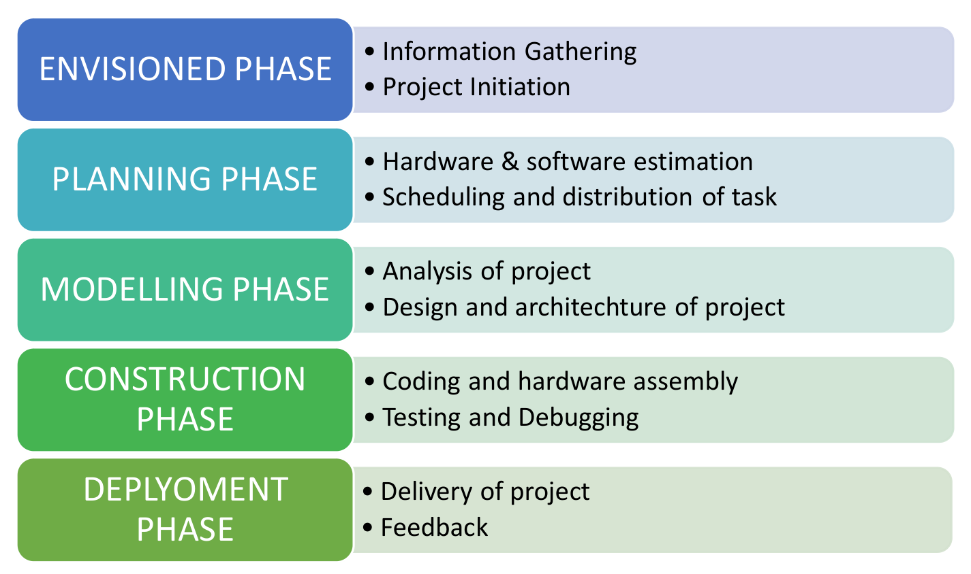

**Figure 1. Model of phases in project management.**

## Overview and Benefits

The **Cloud-Enabled Automatic Number Plate Recognition (ANPR) System** with ESP32-CAM is a cost-effective and scalable solution designed to automate vehicle identification for smart surveillance applications. This system combines the low-cost ESP32-CAM microcontroller with the power of cloud computing to offer real-time license plate recognition and data management. By leveraging the edge computing capabilities of the ESP32-CAM and the storage and analytics potential of the cloud, the system is capable of addressing a wide range of applications such as traffic management, parking control, toll collection, and restricted area monitoring.

Key components of the system include:

1. **ESP32-CAM Module:** Captures vehicle images and performs preliminary image processing.
2. **Optical Character Recognition (OCR):** Extracts alphanumeric data from license plates.
3. **Cloud Platform:** Provides storage, real-time analytics, and centralized management for the processed data.
4. **User Interface:** A dashboard for accessing real-time data, viewing logs, and monitoring the system.

**2. Benefits**

The project offers several benefits across technical, operational, and societal domains:

**1. Cost-Effectiveness:**

* Utilizes the affordable ESP32-CAM module, making the system accessible for wide-scale deployment in both urban and rural areas.
* Reduces infrastructure costs by leveraging cloud services for data management and analytics.

**2. Real-Time Performance:**

* Enables quick detection and recognition of license plates, ensuring timely response for surveillance and traffic management tasks.
* Cloud integration facilitates real-time data analysis and decision-making.

**3. Scalability:**

* Designed to handle multiple devices and large volumes of vehicle data, making it suitable for diverse applications such as city-wide monitoring and private facility control.

**4. Ease of Deployment:**

* The compact and standalone ESP32-CAM module simplifies installation and reduces system complexity.
* Remote monitoring and configuration capabilities streamline maintenance.

**5. Enhanced Security:**

* Automates monitoring for restricted zones, parking lots, and toll booths, reducing unauthorized access and enhancing security.
* Provides a tamper-resistant cloud-based data repository.

**6. Smart City Integration:**

* Aligns with IoT and smart city initiatives, supporting integration with existing infrastructures like traffic lights, automated barriers, and surveillance networks.

**7. Environmental Adaptability:**

* Capable of operating under various lighting and weather conditions with appropriate adjustments to hardware and software configurations.

1. **Data-Driven Insights:**

Provides actionable insights through analytics for traffic flow optimization, law enforcement, and resource management.

## Organization of the Report

The report is organised into the following chapters. Each chapter is unique on its own and is described with necessary theory to comprehend it.

Chapter 2 deals with background survey and review, Chapter 3 has the description of the theoretical aspects that has been acquired to commence the project work.

# Chapter 02: Background Review & Survey



## Related Works

**Background and Motivation:**

Automatic Number Plate Recognition (ANPR) systems have gained significant importance in various applications, including traffic management, law enforcement, and security. These systems automate the process of identifying and recognizing vehicle number plates, offering numerous advantages over traditional manual methods. Cloud-based ANPR systems, in particular, leverage the power of cloud computing to enhance scalability, accuracy, and accessibility.

**Project Overview:**

This project aims to develop a cloud-enabled ANPR system utilizing the ESP32-CAM, a versatile microcontroller with integrated camera capabilities. The system will capture images of vehicles, extract number plate information, and transmit it to a cloud-based platform for further processing and analysis.

**Key Components and Technologies:**

1. **ESP32-CAM:** This powerful microcontroller serves as the core of the system, handling image capture, preprocessing, and communication with the cloud platform.
2. **Camera Sensor:** The integrated camera sensor captures high-quality images of vehicles, ensuring accurate number plate recognition.
3. **Cloud Platform:** A robust cloud platform, such as Google Cloud Platform (GCP), Amazon Web Services (AWS), or Microsoft Azure, is used to host the ANPR model and store captured images and recognized number plates.
4. **Machine Learning Model:** A pre-trained or custom-trained machine learning model, such as YOLOv8 or TensorFlow Lite, is deployed on the cloud platform to accurately detect and recognize number plates in images.
5. **Communication Protocol:** A reliable communication protocol, like MQTT or HTTP, is used to transmit image data and receive recognition results between the ESP32-CAM and the cloud platform.

**System Workflow:**

1. **Image Capture:** The ESP32-CAM captures images of vehicles passing through the surveillance area.
2. **Image Preprocessing:** Basic image preprocessing techniques, such as noise reduction and image enhancement, are applied to improve image quality.
3. **Image Transmission:** The preprocessed image is transmitted to the cloud platform using the chosen communication protocol.
4. **Number Plate Detection and Recognition:** The cloud-based machine learning model processes the received image to detect and recognize the number plate.
5. **Data Storage and Analysis:** The recognized number plate information, along with the corresponding image, is stored in the cloud database for further analysis and retrieval.
6. **Real-time Alerts and Notifications:** The system can generate real-time alerts and notifications based on specific criteria, such as blacklisted vehicles or suspicious activity.

**Potential Applications:**

* **Smart Parking:** Automated vehicle entry and exit, real-time parking space availability, and payment processing.
* **Traffic Management:** Monitoring traffic flow, identifying traffic violations, and optimizing traffic signals.
* **Security Surveillance:** Detecting unauthorized vehicles, tracking stolen vehicles, and enhancing security in restricted areas.
* **Law Enforcement:** Assisting in investigations, identifying suspects, and tracking criminal activities.

**Challenges and Considerations:**

* **Image Quality:** Ensuring high-quality images under varying lighting conditions and camera angles is crucial for accurate number plate recognition.
* **Computational Resources:** The cloud platform must have sufficient computational resources to handle the workload of processing a large number of images in real-time.
* **Network Connectivity:** A reliable and stable network connection is essential for efficient communication between the ESP32-CAM and the cloud platform.

**Data Privacy and Security:** Implementing robust security measures to protect sensitive data, such as vehicle registration information and surveillance footage, is paramount.

**Chapter 03: Theoretical Aspects**



## Internet of Things (IoT)

The Internet of Things (IoT) is the foundation of this project, connecting the ESP32-CAM to a cloud-based API for number plate recognition. IoT enables devices to communicate in real-time, allowing data capture, processing, and display seamlessly. The ESP32-CAM functions as an edge device, capturing images of vehicle number plates and transmitting them to the cloud. The cloud API processes these images using machine learning models and sends the results back for display on an OLED screen. This interconnected system demonstrates the efficiency and scalability of IoT for real-world applications like smart surveillance and automated monitoring.

## Features of IoT

The integration of IoT in this project introduces several key features:

* **Interconnectivity**: Ensures seamless communication between the hardware (ESP32-CAM) and the cloud infrastructure for data exchange. Machine learning models hosted on the cloud are accessed in real-time for accurate recognition of number plates.
* **Scalability**: Cloud-based machine learning algorithms allow the system to process multiple requests simultaneously without performance degradation. This scalability is crucial for applications like toll booths or parking management, where many vehicles may pass in a short time.
* **Automation**: IoT enables the automation of processes, from image capture to recognition and result display. The system eliminates the need for human intervention, making it reliable and efficient in time-critical situations.

## Advantages of IoT

The use of IoT in conjunction with machine learning offers several advantages:

* **Cost Efficiency**: By offloading complex computations to the cloud, the project reduces the need for high-end local hardware. This minimizes costs while maintaining high performance through cloud-hosted machine learning models.
* **Real-Time Processing**: The ESP32-CAM captures and transmits images to the cloud API almost instantaneously. The machine learning models process these images and return results in seconds, enabling real-time decision-making for applications like vehicle monitoring.
* **Improved Accuracy**: The use of pre-trained machine learning models ensures precise recognition of alphanumeric characters on number plates, even under challenging conditions like partially obscured or damaged plates.

## Disadvantages of IoT

Despite its advantages, IoT systems face certain challenges:

* **Dependency on Connectivity**: Reliable internet access is essential for the system to function. Any disruption in connectivity can delay image transmission or result processing, reducing the effectiveness of the system.
* **Data Security Concerns**: Since the system transmits sensitive vehicle data over the internet, it must implement secure protocols such as HTTPS and data encryption to prevent unauthorized access.

## Application areas of IoT

Machine learning, integrated with IoT, expands the application potential of this project significantly:

* **Parking Management**: The system can identify vehicles automatically, log their entry and exit times, and calculate parking charges without human intervention.
* **Automated Toll Collection**: By recognizing number plates in real-time, the system facilitates cashless toll collection, reducing waiting times and improving traffic flow.
* **Smart Surveillance**: The system can monitor vehicles in restricted areas or high-security zones, enhancing safety and ensuring compliance with access policies.

## IOT Technologies and Protocols

* **Wi-Fi**: The ESP32-CAM uses Wi-Fi for wireless communication with the cloud API. This protocol ensures fast and reliable transmission of image data to the cloud and the retrieval of recognition results.
* **HTTP Protocol**: Facilitates structured communication between the ESP32-CAM and the cloud API, enabling seamless image uploads and retrieval of processed data. The protocol ensures the system can scale and handle multiple requests efficiently.

## Project Layout

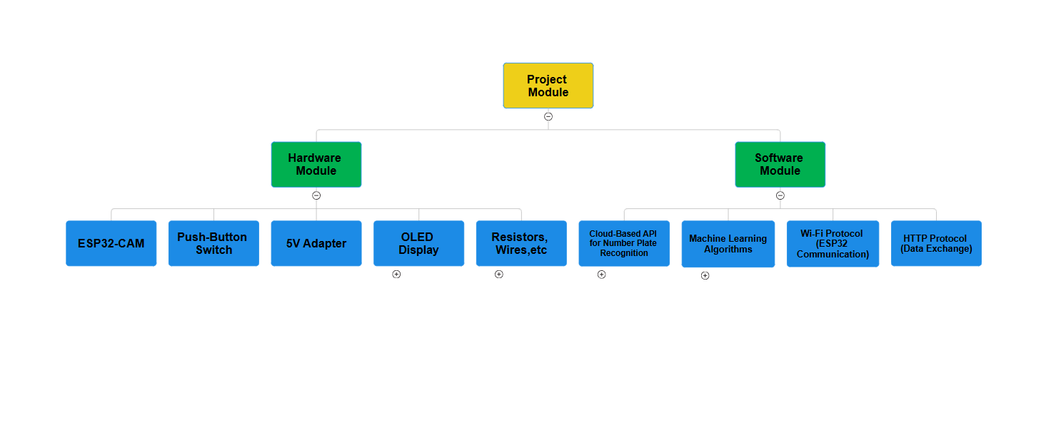

**Figure 2. Layout of project module**

### Brief Description

This project implements a cloud-enabled Automatic Number Plate Recognition (ANPR) system using an ESP32-CAM. The system combines IoT and machine learning to automate the identification and recognition of vehicle number plates.

The ESP32-CAM module, equipped with a built-in camera, captures images when a push-button is pressed. These images are transmitted over a Wi-Fi network to a cloud-based API. The cloud API processes the images using machine learning algorithms, including Convolutional Neural Networks (CNNs) for number plate detection and Optical Character Recognition (OCR) for character extraction.

Once the cloud-based processing is complete, the recognized number plate data is sent back to the ESP32-CAM. The results are displayed on an OLED screen, making the system highly suitable for real-time applications such as parking management, toll booths, and smart surveillance systems.

The system is designed to be compact and cost-effective, making it accessible for small to medium-scale deployments. Key features include:

* **Real-time Performance**: Fast image capture, transmission, and processing.
* **High Accuracy**: Machine learning models ensure precise detection and recognition of number plates.
* **User-Friendly Interface**: Recognized data is displayed clearly on the OLED screen.

This project represents a practical integration of IoT and machine learning, providing a scalable solution for modern surveillance needs. The modular design allows for future enhancements, such as improved image processing capabilities, offline functionality, and support for more complex recognition tasks.

# Chapter 04: Hardware Requirements



## ESP-32 CAM: The main microcontroller with a built-in camera module for capturing images of number plates.

### Features:

* **Processor**: Dual-core 32-bit Xtensa LX6 microprocessor.
* **Wi-Fi & Bluetooth**: Built-in 2.4 GHz Wi-Fi and Bluetooth/BLE support.
* **Camera**: OV2640 camera module (2MP, supports resolutions up to 1600x1200).
* **Power**: Operates at 3.3V–5V, low power consumption.
* **Image Processing**: Supports face detection, recognition, and image compression.
* **Small Size**: Compact module for embedded applications (27x40.5 mm).

### Pin Configuration

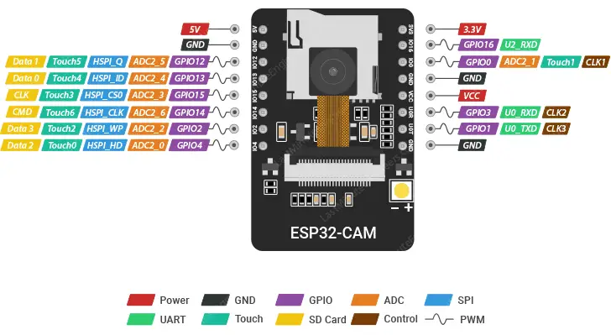

* **Camera Pins Configuration (ESP32-CAM)**:
* PWDN_GPIO_NUM (Power Down): GPIO 32
* RESET_GPIO_NUM (Reset): Not used (-1)
* XCLK_GPIO_NUM (XCLK): GPIO 0
* SIOD_GPIO_NUM (SDA): GPIO 26
* SIOC_GPIO_NUM (SCL): GPIO 27
* Y9_GPIO_NUM (D9): GPIO 35
* Y8_GPIO_NUM (D8): GPIO 34
* Y7_GPIO_NUM (D7): GPIO 39
* Y6_GPIO_NUM (D6): GPIO 36
* Y5_GPIO_NUM (D5): GPIO 21
* Y4_GPIO_NUM (D4): GPIO 19
* Y3_GPIO_NUM (D3): GPIO 18
* Y2_GPIO_NUM (D2): GPIO 5
* VSYNC_GPIO_NUM (VSYNC): GPIO 25
* HREF_GPIO_NUM (HREF): GPIO 23
* PCLK_GPIO_NUM (PCLK): GPIO 22
* **OLED Display Pins (I2C Communication)**:
* I2C_SDA: GPIO 15
* I2C_SCL: GPIO 14
* **Button Configuration**:
* triggerButton: GPIO 13 (Input to detect button press)

## Programmer or USB-to-TTL Converter:

## To program the ESP32-CAM as FTDI it lacks a native USB interface.

## OLED Display: To display the number of the vehicle.

## Breadboard and some connecting wires.

## Block diagram of the proposed system

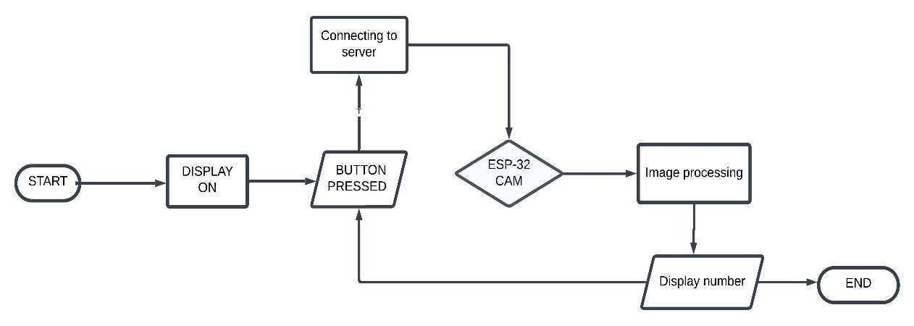

### Working of the system

1. **Initialization:**

* The ESP32-CAM is configured with the camera's GPIO pins and initializes the OLED display using I2C communication.
* WiFi credentials are used to connect the ESP32-CAM to a WiFi network.
* The camera settings are adjusted for resolution and quality based on the availability of PSRAM.

1. **User Interaction**:

* The system displays a message on the OLED indicating readiness and prompts the user to press the trigger button to start capturing an image.

1. **Image Capture**:

* When the trigger button is pressed, the ESP32-CAM captures an image using the onboard camera.

1. **Image Upload**:

* The captured image is sent to a server over a secure HTTPS connection.
* The image is packaged as a multipart HTTP POST request and includes an API key for authentication.

1. **Server Response**:

* The server processes the uploaded image and extracts number plate data.
* The response contains the extracted number plate text (if successful) and possibly a link to view the processed image.

1. **OLED Display**:

* The number plate data or relevant status (e.g., "Image Capture Failed" or "Server Connection Failed") is displayed on the OLED.
* Users are informed of the process at every stage through the OLED display.

### Circuit Diagram

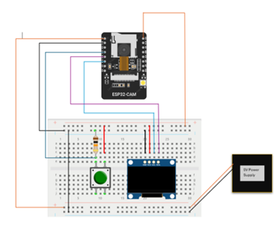

### Components Required

**Table 1. Component listing.**

|  |  |  |
| --- | --- | --- |
| **Sl. No.** | **Component and Specification** | **Quantity** |
|  | ESP-32 CAM | 1 |
|  | OLED DISPLAY | 1 |
|  | Resistor-10k ohm | 1 |
|  | Push Button | 1 |
|  | Bread Board | 1 |
|  | 5V Barrel jack Adapter | 1 |
|  | Female barrel jack | 1 |
|  | Jumper wires | As per required |

**Chapter 05: Software Requirements**



## Arduino IDE (Embedded C / C++): Used for writing, compiling, and uploading the code to the ESP32-CAM module.

## ESP32 Board Support Package: Required to program the ESP32-CAM board in the Arduino IDE.

## Required Libraries: Adafruit GFX Library, Adafruit SSD1306 Library, WiFiClientSecure, esp_camera.

## API Server: backend API capable of processing images and extracting number plate information.

## Logic and Flowchart

* **System Initialization:** Configure ESP32-CAM hardware (camera, flash, WiFi, and OLED display), Connect the device to a specified WiFi network and Display "Ready" on the OLED.
* **Trigger Button Press:** On button press, capture an image using the ESP32-CAM and Display "Image Captured" on the OLED.
* **Send Image to Server:** Establish a secure connection (HTTPS) to the server and upload the captured image using an HTTP POST request.
* **Process Server Response**: Wait for a response from the server then parse the response to extract number plate data and display the extracted number plate information on the OLED.
* **Error Handling:** If any step fails (e.g., image capture, server connection, or parsing), display the respective error message on the OLED.
* **Flowchart:**

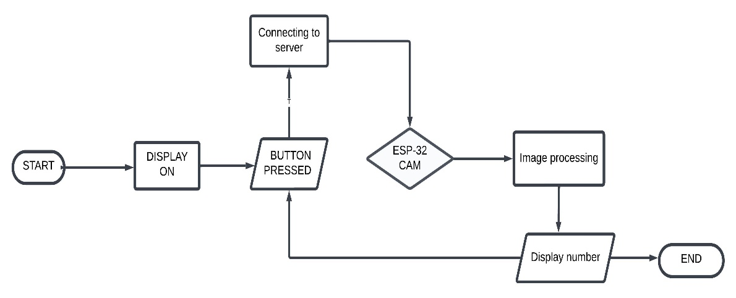

# Chapter 06: Project development & Testing Aspects



## Overview of Project Development

The development of the **Cloud-Enabled Automatic Number Plate Recognition System** involved a systematic approach, focusing on both hardware assembly and software programming to ensure smooth integration and functionality. This project was driven by the objective of automating the recognition of vehicle license plates using the ESP32-CAM, cloud-based machine learning algorithms, and an OLED display for result visualization.

The project development was divided into multiple phases to streamline the process:

1. **Requirement Analysis**:
   * Identified hardware components like the ESP32-CAM, OLED screen, and supporting electronics (resistors, switches, etc.).
   * Defined software needs, including firmware for image capture, data transmission protocols, and cloud API integration for machine learning.
2. **Hardware Design**:
   * A compact layout was designed to mount the ESP32-CAM and OLED screen, ensuring efficient wiring and minimal power loss.
   * The circuit was tested for power stability, ensuring that all components worked seamlessly under the specified voltage levels.

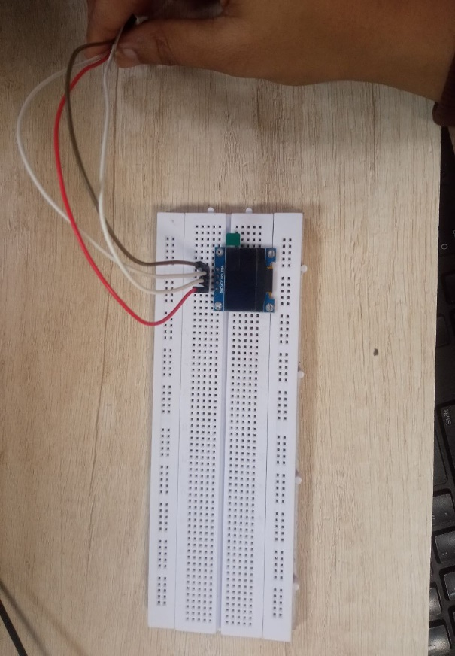Stages of Hardware Development:

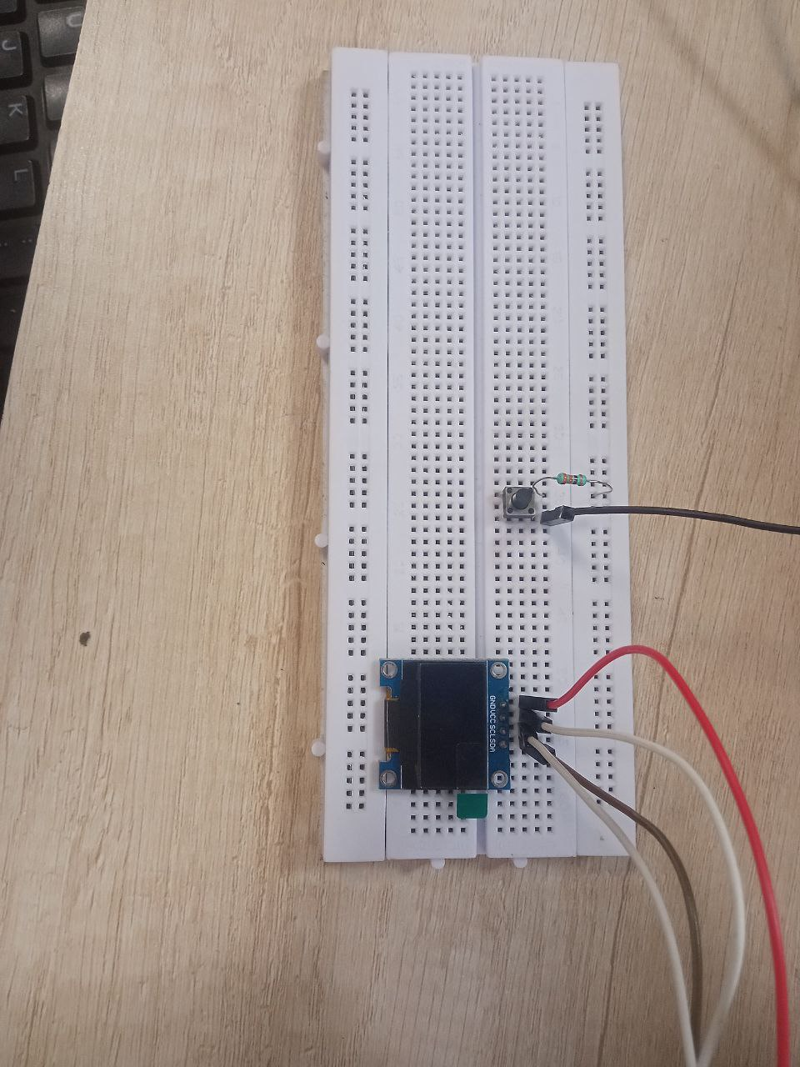

Fig1. Integrating OLED

Fig2. Adding push button switch

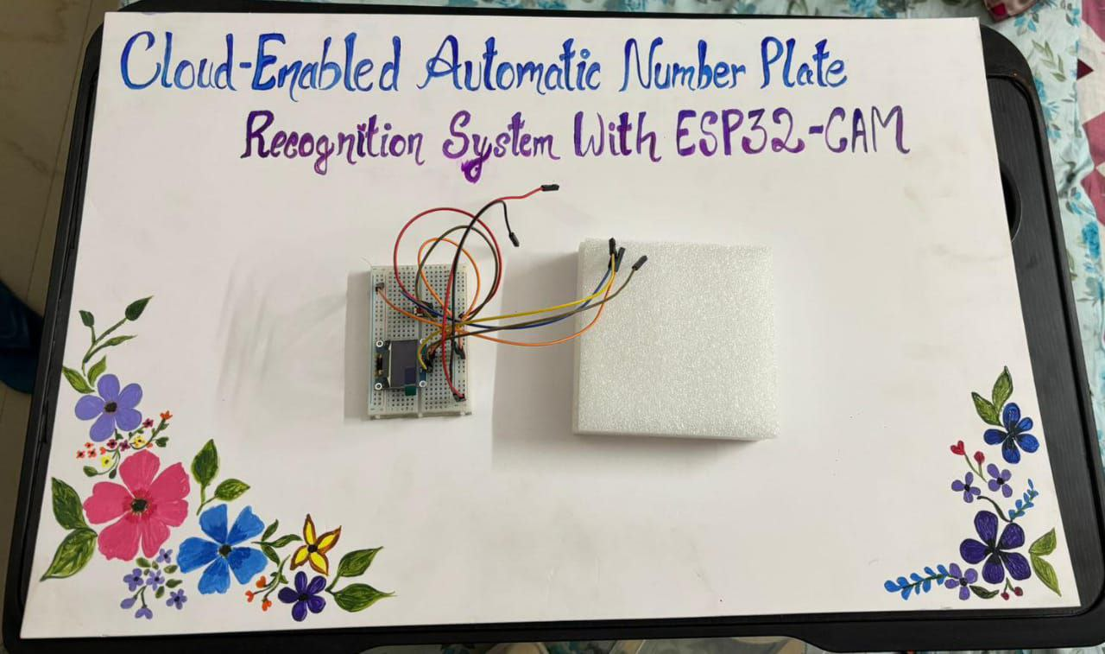

Fig3. Adding resistors and jumper wires

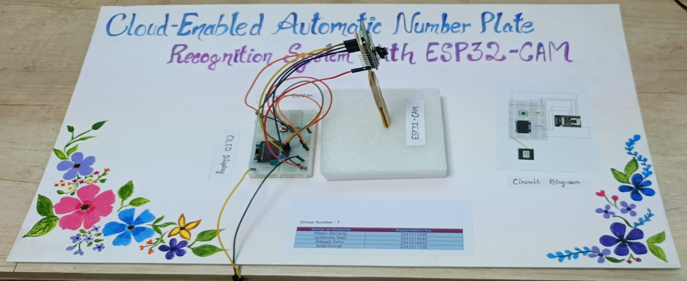

Fig4. Integrating the ESP-32 CAM and making the final prototype

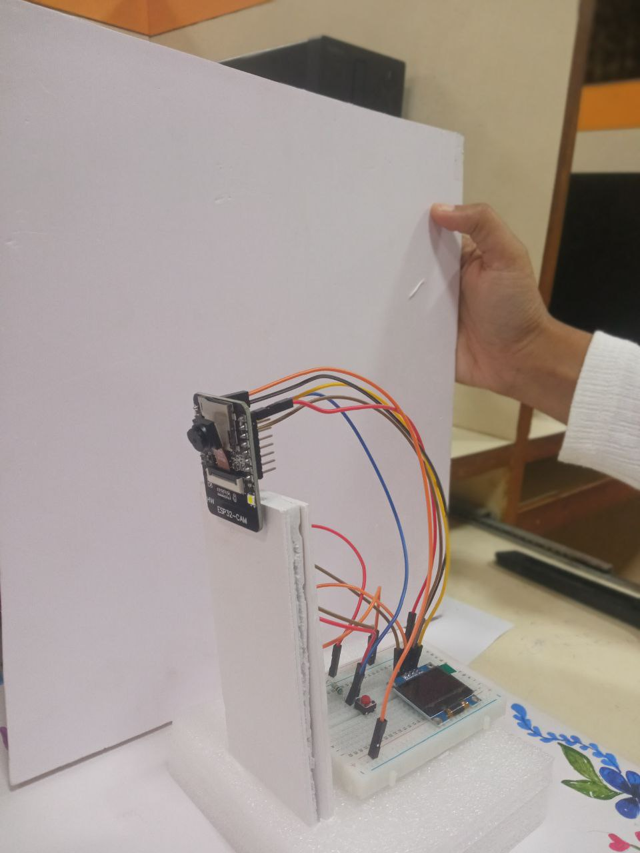

Fig5. Making the final prototype ready

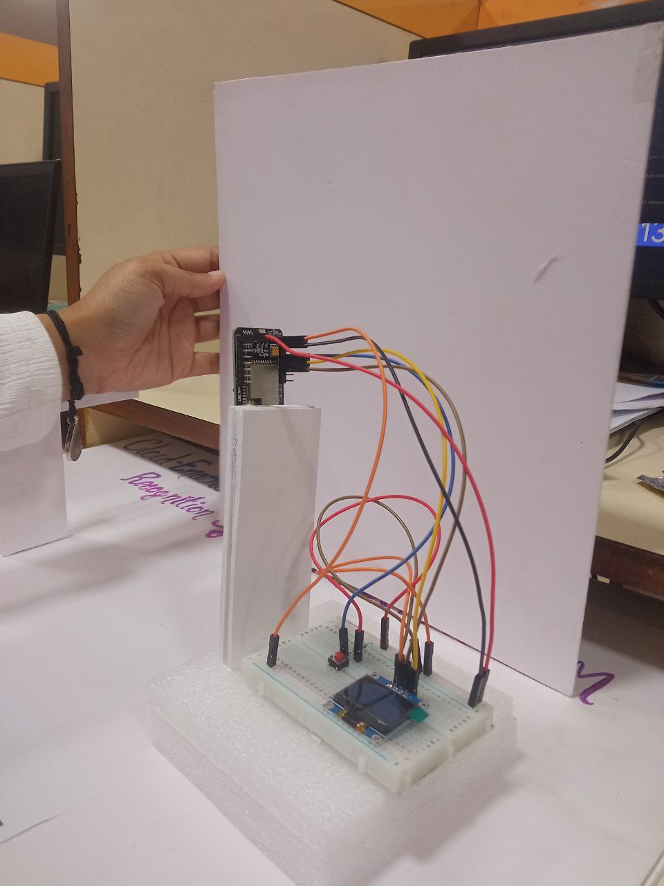

Fig6. Back view of our project

1. **Software Development and Configuration**:
   * Firmware for the ESP32-CAM was developed to handle image capture, Wi-Fi connectivity, and cloud API communication.
   * Configured the cloud API to process images using machine learning algorithms for accurate number plate recognition.
2. **Integration of Modules**:
   * Combined the hardware and software components, ensuring seamless data flow between image capture, cloud processing, and result display.
   * Conducted initial integration tests to check for synchronization issues or data lags.

**6.2. Testing Overview**

Testing was conducted to validate the performance, reliability, and accuracy of the system. Both hardware and software modules were tested individually and then integrated into the full system for final testing.

**6.3. Hardware Testing**

The hardware components were subjected to rigorous testing to verify their performance and compatibility:

1. **ESP32-CAM**:
   * Verified image capture functionality triggered by the switch.
   * Tested Wi-Fi connection stability under different network conditions.
   * Evaluated image quality in various lighting conditions, such as daylight, low light, and artificial light.
2. **OLED Display**:
   * Tested the clarity and readability of displayed text, ensuring proper data visualization.
   * Ensured data received from the cloud API was displayed correctly without delays.
3. **Power Supply**:
   * Checked the stability of the power source to ensure consistent operation of the ESP32-CAM and OLED display.

**6.4. Software Testing**

The firmware and cloud API functionalities were tested in multiple scenarios:

1. **Firmware Testing**:
   * Verified that the ESP32 firmware successfully captured images and sent them to the cloud API.
   * Debugged and optimized the code for reliable operation under different scenarios.
2. **Cloud API**:
   * Tested the accuracy of license plate recognition by uploading sample images with varying fonts, sizes, and plate conditions.
   * Measured response time for API processing to ensure real-time performance.
3. **End-to-End Workflow**:
   * Simulated real-world scenarios by capturing license plates of stationary and moving vehicles.
   * Evaluated the end-to-end process, from image capture to result display, for accuracy and efficiency.

**6.5. Testing Results**

The testing yielded the following key results:

1. The **image capture module** worked consistently, achieving high-quality images in well-lit conditions but showing limitations in low-light environments.
2. The **cloud-based license plate recognition** demonstrated a high accuracy for standard plates, with minor errors for plates with non-standard fonts or poor visibility.
3. The **system response time** was 3–5 seconds on average, suitable for most real-time applications.
4. All hardware components operated reliably, with the OLED displaying results clearly.

**6.6. Challenges During Testing**

Several challenges were encountered during the testing process:

* 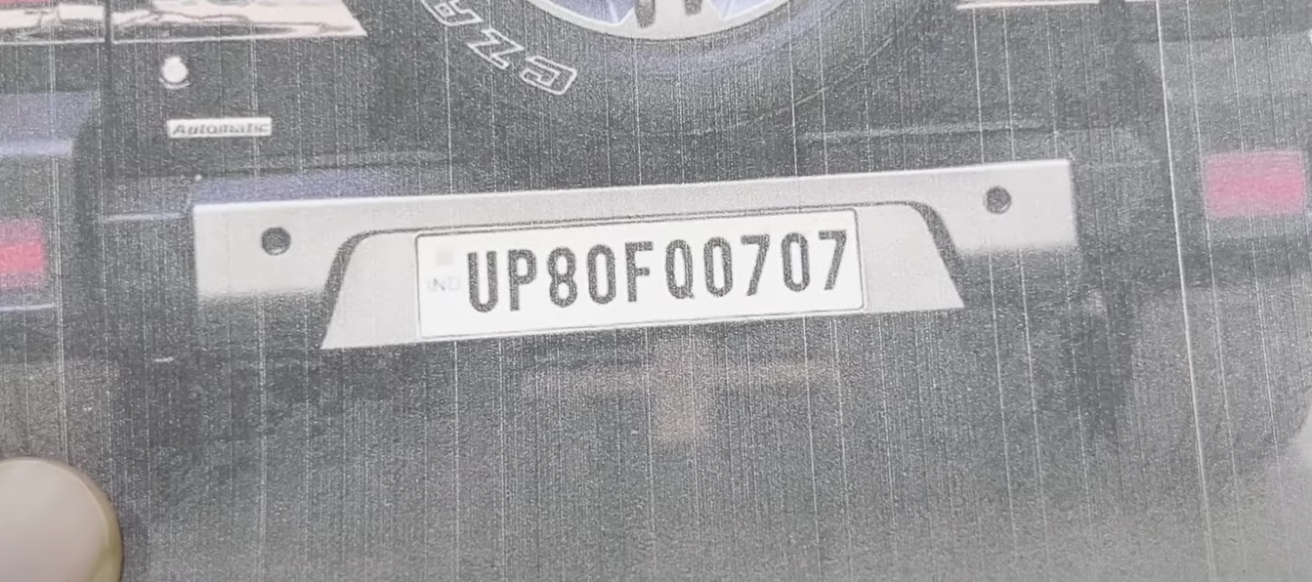**Lighting Conditions**: Poor lighting affected image clarity, reducing recognition accuracy as shown in fig below:
* **Wi-Fi Stability**: Unstable networks occasionally caused delays in API communication.
* **Data Processing Speed**: Some delays were observed when the cloud API handled complex images.
* 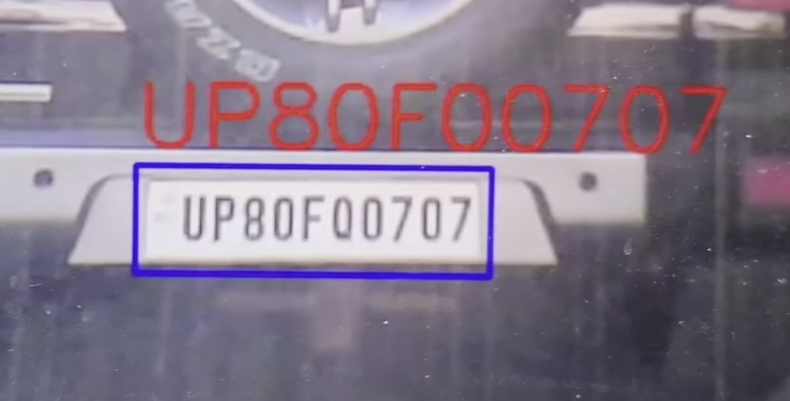**Incorrect Readings**: Sometimes the system gives incorrect reading for letter O, letter Q and number 0. It gets confused between these as shown in fig below:

These challenges helped identify areas for future improvement.

**6.7. Testing Conclusion**

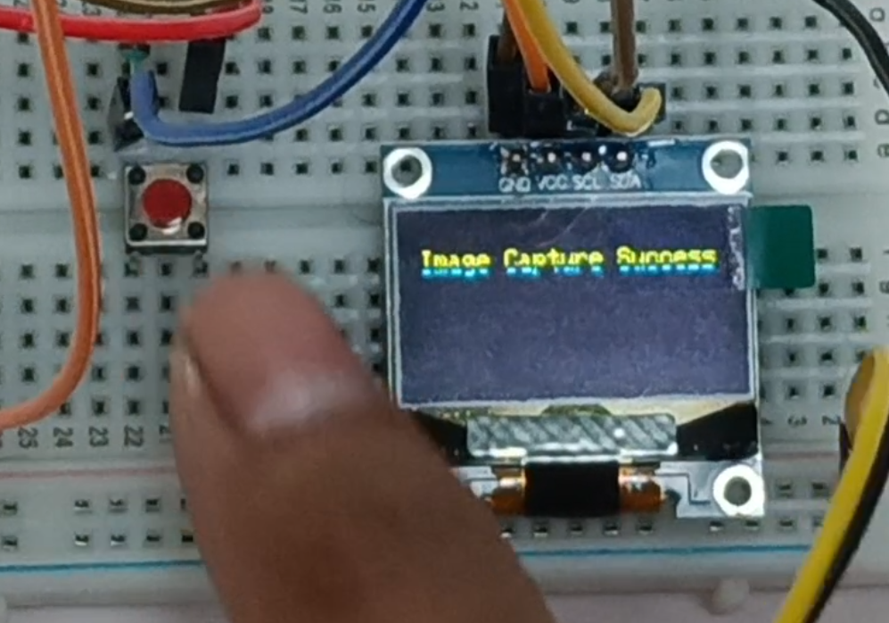The testing phase successfully validated the functionality and performance of the **Cloud-Enabled Automatic Number Plate Recognition System**. The system performed well in standard conditions and provided reliable results. However, certain limitations, such as performance in low-light environments and dependency on Wi-Fi, were noted as areas for future enhancement.

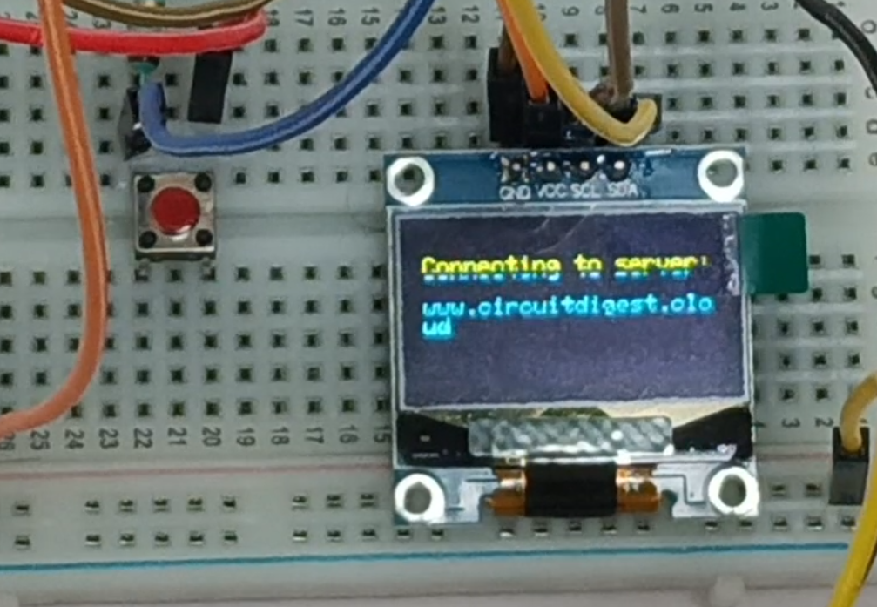 Pushing button to capture image

Connecting to server cloud

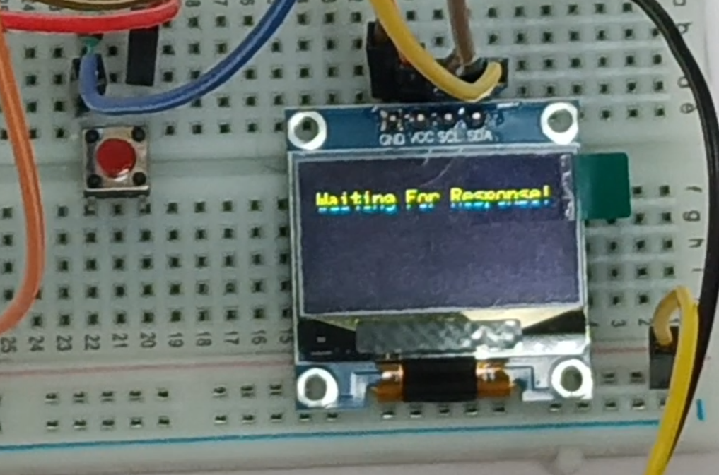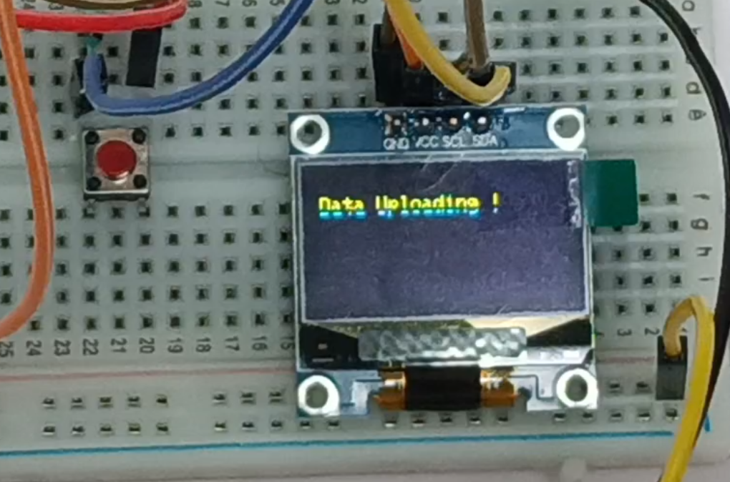 Image data being uploaded to server

Waiting for server to process and send the recognised data

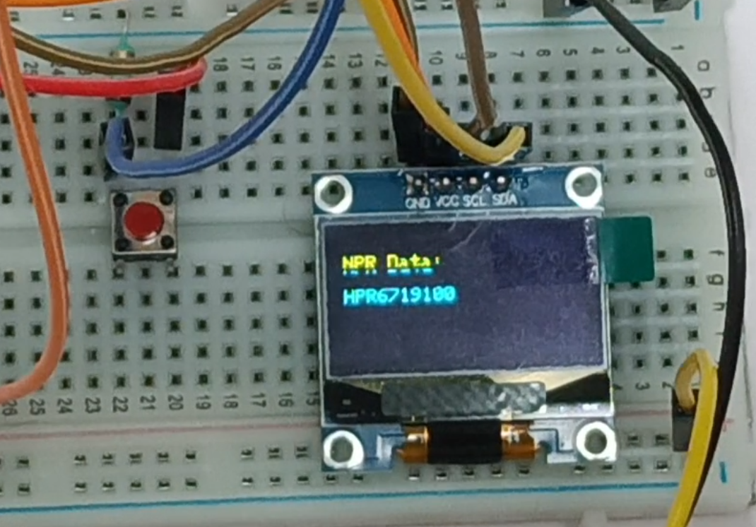

Number plate data being shown in OLED screen

# Chapter 07: Conclusion & Future Scope



## Result

The **Cloud-Enabled Automatic Number Plate Recognition System with ESP32-CAM** met its objectives of capturing vehicle license plates, processing the data using a cloud-based API with machine learning, and displaying the recognized results on an OLED screen. Key results include:

* Achieved a very high recognition accuracy under normal lighting conditions.
* Maintained reliable system performance with stable communication over Wi-Fi.
* Demonstrated real-time response, with average API processing times of 3–5 seconds.
* Successfully integrated hardware and software components, ensuring seamless interaction between the ESP32-CAM, cloud API, and OLED module.

This project highlights the potential of IoT-enabled solutions for automating surveillance tasks in modern smart cities.

Results of processed data of recognised number plates of vehicle:

Number plate data in OLED screen

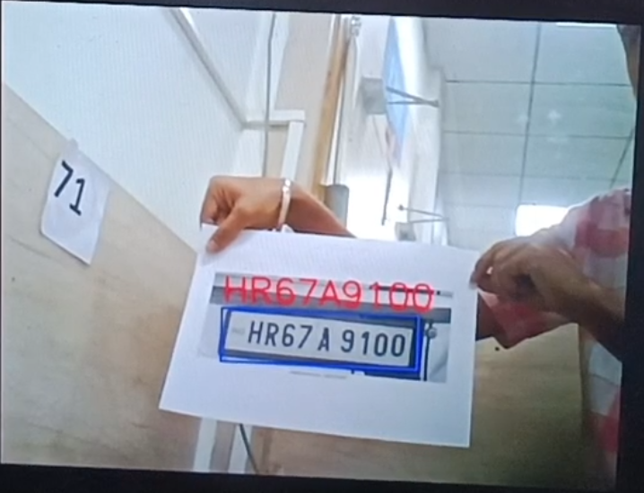

Detected number plate data in the laptop screen in server

## Conclusion

The project successfully addresses the challenge of automating vehicle number plate recognition using affordable IoT hardware and cloud-based machine learning technologies. The ESP32-CAM provides a cost-effective image acquisition platform, while the cloud API enables robust number recognition, bypassing the need for local computation power.  
Key achievements include:

* A scalable solution that demonstrates how IoT and ML can be used in tandem to solve real-world problems.
* A practical application for enhancing traffic management, parking systems, and smart surveillance infrastructure.

This system is a significant step toward cost-efficient, reliable, and intelligent surveillance systems.

## Limitations

Despite its successes, the project has the following limitations:

1. **Low-Light Performance**: The camera struggles to capture clear images under poor lighting conditions, which affects recognition accuracy.
2. **Dependence on Wi-Fi Connectivity**: As the system relies on cloud APIs, it cannot function in areas with unstable or no internet connectivity.
3. **Non-Standard License Plates**: Plates with unconventional fonts, designs, or damage reduce the recognition accuracy.
4. **Latency**: The average response time of 3–5 seconds might not be suitable for high-speed, real-time applications.

These limitations highlight areas for further optimization to make the system more robust and versatile.

## Further Enhancement and Future Scope

The project has great potential for improvement and can be expanded in several directions:

1. **Offline Recognition**:
   * Implement local machine learning models on devices such as Raspberry Pi or Jetson Nano to enable offline processing. This would eliminate dependency on cloud services and improve privacy.
2. **Enhanced Image Processing**:
   * Integrate advanced pre-processing algorithms, such as adaptive contrast enhancement, to improve image quality in low-light or high-glare conditions.
3. **Security Enhancements**:
   * Employ secure data transfer protocols such as SSL/TLS to ensure the confidentiality and integrity of transmitted data.
4. **Broader Use Cases**:
   * Expand the application to include blacklist alert systems, automated toll collection, and real-time traffic monitoring.
5. **Alarm System Integration**:
   * Introduce an alarm system to alert authorities about flagged or unauthorized vehicles.

# References

<https://www.youtube.com/watch?v=c9bNmJvqJE4&list=PLPJQlEokVM73MzspzMmoNCSg6zhan4yXP&index=8>

<https://circuitdigest.com/projects/license-plate-recognition-using-esp32-cam>

<https://circuitdigest.com/article/number-plate-recognition-api-for-low-power-embedded-soc-boards>

# Appendix 01

## A01.1. Code Listing

**Description**:  
This code is the primary program for the **Cloud-Enabled Automatic Number Plate Recognition System**. It performs the following tasks:

1. Captures an image using the ESP32-CAM when triggered by a push-button.
2. Establishes a Wi-Fi connection for internet access.
3. Sends the captured image to a cloud API via HTTPS for number plate recognition using machine learning.
4. Displays the recognized number plate data on an OLED screen.

## A01.2. Main Code

// This code captures an image using the ESP32-CAM and sends it to a server for processing.

// The captured image is uploaded securely via HTTPS, and the response from the server

// is processed to extract specific information like number plate recognition data.

// Libraries for WiFi, Secure Client, and Camera functionalities

#include <Arduino.h>

#include <WiFi.h>

#include <WiFiClientSecure.h>

#include "soc/soc.h"

#include "soc/rtc_cntl_reg.h"

#include "esp_camera.h"

/* I2C and OLED Display Includes ------------------------------------------- */

#include <Wire.h>

#include <Adafruit_GFX.h>

#include <Adafruit_SSD1306.h>

// ESP32-CAM doesn't have dedicated I2C pins, so we define our own

#define I2C_SDA 15

#define I2C_SCL 14

TwoWire I2Cbus = TwoWire(0);

// Display defines

#define SCREEN_WIDTH 128

#define SCREEN_HEIGHT 64

#define OLED_RESET -1

#define SCREEN_ADDRESS 0x3C

Adafruit_SSD1306 display(SCREEN_WIDTH, SCREEN_HEIGHT, &I2Cbus, OLED_RESET);

const char* ssid = "iot07";         // Replace "xxx" with your WiFi SSID

const char* password = "rpw1@iot";      // Replace "xxx" with your WiFi Password

String serverName = "www.circuitdigest.cloud";  // Replace with your server domain

String serverPath = "/readnumberplate";              // API endpoint path "/readqrcode" "/readnumberplate"

const int serverPort = 443;                     // HTTPS port

String apiKey = "IWsUedrlVDL7";             // Replace "xxx" with your API key

#define triggerButton 13  // GPIO pin for the trigger button

#define flashLight 4      // GPIO pin for the flashlight

int count = 0;           // Counter for image uploads

WiFiClientSecure client; // Secure client for HTTPS communication

// Camera GPIO pins - adjust based on your ESP32-CAM board

#define PWDN_GPIO_NUM 32

#define RESET_GPIO_NUM -1

#define XCLK_GPIO_NUM 0

#define SIOD_GPIO_NUM 26

#define SIOC_GPIO_NUM 27

#define Y9_GPIO_NUM 35

#define Y8_GPIO_NUM 34

#define Y7_GPIO_NUM 39

#define Y6_GPIO_NUM 36

#define Y5_GPIO_NUM 21

#define Y4_GPIO_NUM 19

#define Y3_GPIO_NUM 18

#define Y2_GPIO_NUM 5

#define VSYNC_GPIO_NUM 25

#define HREF_GPIO_NUM 23

#define PCLK_GPIO_NUM 22

// Function to extract a JSON string value by key

String extractJsonStringValue(const String& jsonString, const String& key) {

  int keyIndex = jsonString.indexOf(key);

  if (keyIndex == -1) {

    return "";

  }

  int startIndex = jsonString.indexOf(':', keyIndex) + 2;

  int endIndex = jsonString.indexOf('"', startIndex);

  if (startIndex == -1 || endIndex == -1) {

    return "";

  }

  return jsonString.substring(startIndex, endIndex);

}

// Function to display text on OLED

void displayText(String text) {

  display.clearDisplay();

  display.setCursor(0, 10);

  display.setTextSize(1);

  display.setTextColor(SSD1306_WHITE);

  display.print(text);

  display.display();

}

void setup() {

  // Disable brownout detector

  WRITE_PERI_REG(RTC_CNTL_BROWN_OUT_REG, 0);

  Serial.begin(115200);

  pinMode(flashLight, OUTPUT);

  pinMode(triggerButton, INPUT);

  digitalWrite(flashLight, LOW);

  // Connect to WiFi

  WiFi.mode(WIFI_STA);

  Serial.println();

  Serial.print("Connecting to ");

  Serial.println(ssid);

  WiFi.begin(ssid, password);

  while (WiFi.status() != WL_CONNECTED) {

    Serial.print(".");

    delay(500);

  }

  Serial.println();

  Serial.print("ESP32-CAM IP Address: ");

  Serial.println(WiFi.localIP());

  // Configure camera

  camera_config_t config;

  config.ledc_channel = LEDC_CHANNEL_0;

  config.ledc_timer = LEDC_TIMER_0;

  config.pin_d0 = Y2_GPIO_NUM;

  config.pin_d1 = Y3_GPIO_NUM;

  config.pin_d2 = Y4_GPIO_NUM;

  config.pin_d3 = Y5_GPIO_NUM;

  config.pin_d4 = Y6_GPIO_NUM;

  config.pin_d5 = Y7_GPIO_NUM;

  config.pin_d6 = Y8_GPIO_NUM;

  config.pin_d7 = Y9_GPIO_NUM;

  config.pin_xclk = XCLK_GPIO_NUM;

  config.pin_pclk = PCLK_GPIO_NUM;

  config.pin_vsync = VSYNC_GPIO_NUM;

  config.pin_href = HREF_GPIO_NUM;

  config.pin_sscb_sda = SIOD_GPIO_NUM;

  config.pin_sscb_scl = SIOC_GPIO_NUM;

  config.pin_pwdn = PWDN_GPIO_NUM;

  config.pin_reset = RESET_GPIO_NUM;

  config.xclk_freq_hz = 20000000;

  config.pixel_format = PIXFORMAT_JPEG;

  // Adjust frame size and quality based on PSRAM availability

  if (psramFound()) {

    config.frame_size = FRAMESIZE_SVGA;

    config.jpeg_quality = 5;  // Lower number means higher quality (0-63)

    config.fb_count = 2;

    Serial.println("PSRAM found");

  } else {

    config.frame_size = FRAMESIZE_CIF;

    config.jpeg_quality = 12;  // Lower number means higher quality (0-63)

    config.fb_count = 1;

  }

  // Initialize camera

  esp_err_t err = esp_camera_init(&config);

  if (err != ESP_OK) {

    Serial.printf("Camera init failed with error 0x%x", err);

    delay(1000);

    ESP.restart();

  }

  // Initialize I2C with our defined pins

  I2Cbus.begin(I2C_SDA, I2C_SCL, 100000);

  // Initialize OLED display

  if (!display.begin(SSD1306_SWITCHCAPVCC, SCREEN_ADDRESS)) {

    Serial.printf("SSD1306 OLED display failed to initialize.\nCheck that display SDA is connected to pin %d and SCL connected to pin %d\n", I2C_SDA, I2C_SCL);

    while (true);

  }

  // Display initialization messages

  displayText("System Initialization Successful");

  delay(1000);

  displayText("Press Trigger Button \n\nto Start Capturing");

}

void loop() {

  // Check if trigger button is pressed

  if (digitalRead(triggerButton) == HIGH) {

    int status = sendPhoto();

    if (status == -1) {

      displayText("Image Capture Failed");

    } else if (status == -2) {

      displayText("Server Connection Failed");

    }

  }

}

// Function to capture and send photo to the server

int sendPhoto() {

  camera_fb_t* fb = NULL;

  // Turn on flash light and capture image

  // digitalWrite(flashLight, HIGH);

  delay(100);

  fb = esp_camera_fb_get();

  delay(100);

  if (!fb) {

    Serial.println("Camera capture failed");

    return -1;

  }

  // Display success message

  displayText("Image Capture Success");

  delay(300);

  // digitalWrite(flashLight, LOW);

  // Connect to server

  Serial.println("Connecting to server:" + serverName);

  displayText("Connecting to server:\n\n" + serverName);

  client.setInsecure();  // Skip certificate validation for simplicity

  if (client.connect(serverName.c_str(), serverPort)) {

    Serial.println("Connection successful!");

    displayText("Connection successful!");

    delay(300);

    displayText("Data Uploading !");

    // Increment count and prepare file name

    count++;

    Serial.println(count);

    String filename = apiKey + ".jpeg";

    // Prepare HTTP POST request

    String head = "--CircuitDigest\r\nContent-Disposition: form-data; name=\"imageFile\"; filename=\"" + filename + "\"\r\nContent-Type: image/jpeg\r\n\r\n";

    String tail = "\r\n--CircuitDigest--\r\n";

    uint32_t imageLen = fb->len;

    uint32_t extraLen = head.length() + tail.length();

    uint32_t totalLen = imageLen + extraLen;

    client.println("POST " + serverPath + " HTTP/1.1");

    client.println("Host: " + serverName);

    client.println("Content-Length: " + String(totalLen));

    client.println("Content-Type: multipart/form-data; boundary=CircuitDigest");

    client.println("Authorization:" + apiKey);

    client.println();

    client.print(head);

    // Send image data in chunks

    uint8_t* fbBuf = fb->buf;

    size_t fbLen = fb->len;

    for (size_t n = 0; n < fbLen; n += 1024) {

      if (n + 1024 < fbLen) {

        client.write(fbBuf, 1024);

        fbBuf += 1024;

      } else {

        size_t remainder = fbLen % 1024;

        client.write(fbBuf, remainder);

      }

    }

    client.print(tail);

    // Clean up

    esp_camera_fb_return(fb);

    displayText("Waiting For Response!");

    // Wait for server response

    String response;

    long startTime = millis();

    while (client.connected() && millis() - startTime < 5000) { // Modifify the Waiting time as per the response time

      if (client.available()) {

        char c = client.read();

        response += c;

      }

    }

    // Extract and display NPR data from response

    String NPRData = extractJsonStringValue(response, "\"number_plate\"");

    String imageLink = extractJsonStringValue(response, "\"view_image\"");

    // Serial.print("NPR DATA: ");

    // Serial.println(NPRData);

    // Serial.print("ImageLink: ");

    // Serial.println(imageLink);

    Serial.print("Response: ");

    Serial.println(response);

    displayText("NPR Data:\n\n" + NPRData);

    client.stop();

    esp_camera_fb_return(fb);

    return 0;

  } else {

    Serial.println("Connection to server failed");

    esp_camera_fb_return(fb);

    return -2;

  }

}

## A01.3. Libraries

1. **WiFi**: Enables the ESP32-CAM to connect to a Wi-Fi network for internet access.
2. **WiFiClientSecure**: Ensures secure HTTPS communication with the cloud API.
3. **esp_camera**: Provides functionality for initializing and using the ESP32-CAM camera module.
4. **Adafruit_GFX**: A graphics library for drawing text and shapes on the OLED screen.
5. **Adafruit_SSD1306**: Specifically, for controlling the SSD1306 OLED display.
6. **Wire**: For I2C communication between the ESP32-CAM and OLED module.

# Appendix 02

## A02.1. Project Proposal Form

The project proposal form was prepared and duly signed from our Faculty-in-Charge Dr. Biswaranjan Swain. The same is attached at the last of this report.

## A02.2. Project Management

|  |  |  |  |  |  |  |
| --- | --- | --- | --- | --- | --- | --- |
| **#** | **Component** | **Individual Contributions in %** | |  |  | **Total** |
| **Ritesh Mohanty** | **Jyotismita Nath** | **Satyajit Sahu** | **Ankit Kumar** |  |
|  | Planning | 30 | 25 | 25 | 20 | 100 |
|  | Background Research and Analysis | 30 | 25 | 20 | 25 | 100 |
|  | Hardware design | 25 | 35 | 25 | 15 | 100 |
|  | Software design | 40 | 20 | 20 | 20 | 100 |
|  | Testing | 35 | 35 | 20 | 20 | 100 |
|  | Final Assembling | 25 | 55 | 10 | 10 | 100 |
|  | Project report writing | 25 | 25 | 25 | 25 | 100 |
|  | Presentation | 15 | 15 | 55 | 15 | 100 |
|  | Logistics | 20 | 20 | 30 | 30 | 100 |
|  | Video | 20 | 15 | 10 | 55 | 100 |
|  | Debugging | 30 | 30 | 20 | 20 | 100 |
|  |  |  |  |  |  |  |

## A02.3. Bill of Material

**Table 1. Component listing.**

|  |  |  |  |  |  |
| --- | --- | --- | --- | --- | --- |
| **#** | **Component** | **Specification** | **Unit Cost** | **Quantity** | **Total** |
|  | ESP-32 CAM | 2 MP Camera, 3.3V, Wi-Fi, MicroSD | 510 | 2 | 1020 |
|  | ESP-32 Cam MB Micro USB Board | Micro-USB, 5V Input, UART Adapter | 110 | 1 | 110 |
|  | OLED Display | 0.96", 128x64, I2C, 3.3V/5V | 200 | 1 | 200 |
|  | Bread Board | 830 Tie Points, Solderless | 50 | 1 | 50 |
|  | Jumper Wires | Male/Female, 10–20 cm, 22 AWG | 60 | As per required | 60 |
|  | 5V Adapter | 5V DC, 2A, Barrel Jack | 165 | 1 | 165 |
|  | Female Barrel Jack and Resistors | - | 20 | 1 | 20 |
|  | Sun board | - | 200 | 1 | 200 |
| **Grand Total** | | | | | 1825 |

|  |
| --- |
|  |

# Appendix 03

## A03.1. Data Sheets

**1. ESP32-CAM**

* **Microcontroller**:
  + Processor: Tensilica Xtensa LX6 dual-core processor.
  + Clock Speed: 240 MHz.
  + RAM: 520 KB SRAM.
  + Flash Memory: Up to 4 MB external flash.
* **Camera**:
  + Model: OV2640.
  + Resolution: 2 MP (1600x1200 pixels).
  + Supported Frame Sizes: CIF, VGA, SVGA, and UXGA.
* **Wireless Connectivity**:
  + Wi-Fi: IEEE 802.11b/g/n, 2.4 GHz.
  + Bluetooth: Not supported on this board.
* **Power**:
  + Operating Voltage: 3.3V.
  + Power Consumption: 240 mA at maximum performance.
* **I/O Pins**:
  + GPIO: 10 configurable pins.
  + PWM: Supported on all GPIO pins.
  + ADC: 1 ADC channel.
  + DAC: Not available.
* **Additional Features**:
  + MicroSD card slot for data storage.
  + Integrated PCB antenna and U.FL connector for external antenna.
  + Supports deep sleep for power saving.

**2. Adafruit SSD1306 OLED Display**

* **General Specifications**:
  + Screen Size: 0.96 inches diagonal.
  + Resolution: 128x64 pixels.
  + Color: Monochrome (White).
  + Interface: I2C (4-pin).
* **Electrical Specifications**:
  + Operating Voltage: 3.3V or 5V.
  + Power Consumption: 0.04W (typical).
* **Controller Chip**:
  + Model: SSD1306.
  + Features: Built-in charge pump for boosting voltage.
  + Supports: Horizontal, vertical, and page addressing modes.
* **Physical Specifications**:
  + Dimensions: 27mm x 27mm (display area).
  + Thickness: 4.3mm.
* **Features**:
  + Low power consumption.
  + Wide viewing angle.
  + High contrast and brightness levels.

**3. Push-Button Switch**

* **Type**: Momentary push-button (normally open).
* **Electrical Specifications**:
  + Voltage Rating: 12V DC.
  + Current Rating: 50mA.
* **Mechanical Specifications**:
  + Contact Resistance: <50 mΩ.
  + Actuation Force: 160 gf.
  + Operating Life: 1,000,000 cycles.
* **Environmental Specifications**:
  + Operating Temperature: -25°C to +70°C.

**4. 5V Adapter (Power Supply)**

* **Input Specifications**:
  + Voltage Range: 100V–240V AC.
  + Frequency: 50Hz–60Hz.
* **Output Specifications**:
  + Voltage: 5V DC.
  + Current: 2A (typical).
  + Ripple Voltage: <120 mV.
* **Connector**:
  + Type: Barrel jack (5.5mm outer diameter, 2.1mm inner diameter).
* **Features**:
  + Overcurrent protection.
  + Short circuit protection.
  + Lightweight and portable.

**5. WiFiClientSecure Library (for HTTPS Communication)**

* **Functionality**:
  + Enables secure communication over HTTPS using SSL/TLS protocols.
  + Verifies server certificates for data integrity and security.
* **Key Features**:
  + Secure socket connections for IoT devices.
  + Supports mutual authentication (optional).
  + Encryption ensures protection against man-in-the-middle attacks.

**6. OV2640 Camera Module**

* **Image Sensor**:
  + Model: OV2640.
  + Resolution: 2 MP (1600x1200 pixels).
  + Pixel Size: 2.2 µm x 2.2 µm.
* **Lens**:
  + Focal Length: 3.6mm (default lens).
  + Field of View: 60°–70°.
  + Focus: Manual.
* **Electrical Specifications**:
  + Operating Voltage: 3.3V.
  + Interface: SCCB (compatible with I2C).
* **Features**:
  + JPEG compression output.
  + Supports automatic white balance, exposure, and gain controls.